[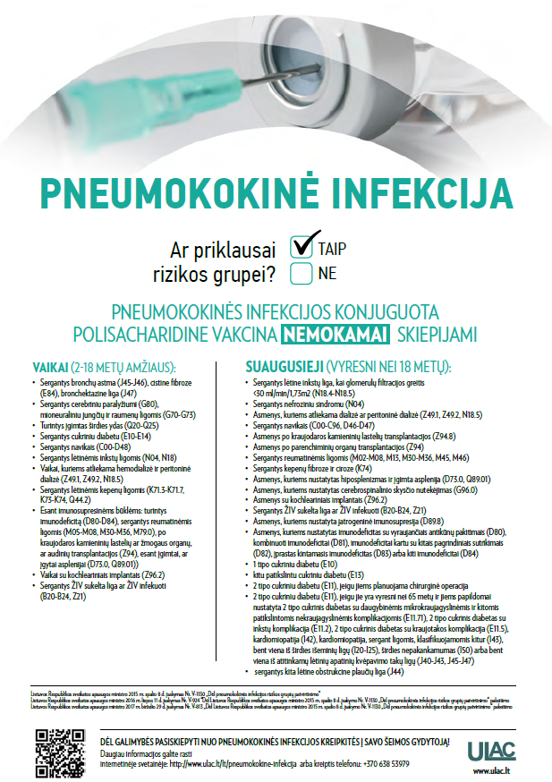](http://www.ulac.lt/uploads/downloads/Pneumokokine_plakatas.pdf)